**The true Antarctic species, those that breed on or near continental Antarctica**

[More](https://www.coolantarctica.com/Antarctica%20fact%20file/wildlife/adelie-penguin.php)

**Emperor penguin**Aptenodytes forsteri  
  
[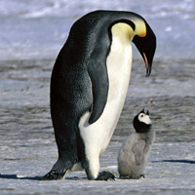](https://www.coolantarctica.com/Antarctica%20fact%20file/wildlife/emp14.jpg)

**Height**: 1.15m - 3.8ft  
  
**Weight**: 30kg - 66lb **Breeding Season:**  
April - December **Distribution:**Continental Antarctica on the sea-ice, the most southerly of all species of penguins. **Estimated population:**  
238, 000 breeding pairs,  
595, 000 individuals

[More](https://www.coolantarctica.com/Antarctica%20fact%20file/wildlife/Emperor-penguins.php)

**King penguin**Aptenodytes patagonica

[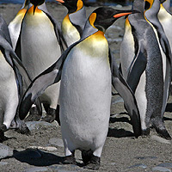](https://www.coolantarctica.com/Antarctica%20fact%20file/wildlife/kings8.jpg)

**Height:** 95cm - 3.1 ft  
  
**Weight:** 15kg - 33lb  **Breeding Season:**  
Starts in November or January, complex breeding system, early or late breeders - raise 2 chicks every 3 years.  
  
**Distribution:**sub-Antarctic islands 46° to 55° South. Biggest colony is on South Georgia. **Estimated population:**  
2 to 3.2 million breeding pairs

[More](https://www.coolantarctica.com/Antarctica%20fact%20file/wildlife/King-penguins.php)

**Rockhopper penguin**Eudyptes crestatus

[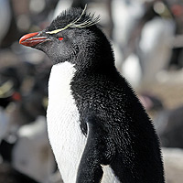](https://www.coolantarctica.com/Antarctica%20fact%20file/wildlife/Rockhopper_Penguin_Liam-Quinn-from-Canada-CC2SaSA.jpg)

**Height:** 55cm - 21.6 inches  
  
**Weight:** 2.5kg - 5.5lb  **Breeding Season:**  
December - March **Distribution:**  
Falkland islands and sub-Antarctic islands north of the Antarctic convergence. **Estimated population:**  
1.8 million breeding pairs  
Many populations are in decline by 40% and up to 94% for certain colonies.

**Antarctica** is the coldest continent on earth, and has a**climate** of extremes. The continent is snow- and ice-covered, with freezing temperatures all year round. So-called "Catabian winds" can cause violent snowstorms that can last for days, and sometimes even weeks, making it very dangerous to stay outside.

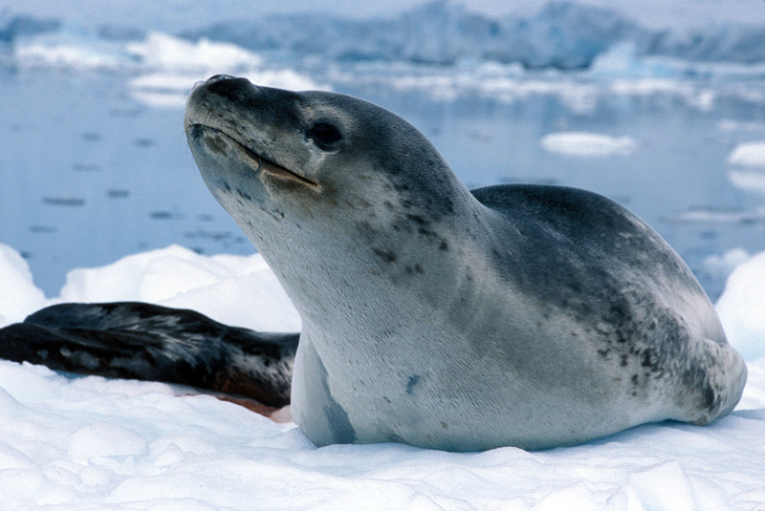

## **They’re the Third Largest Seal in the World**

## Female leopard seals, the larger of the two sexes, can reach weights of 590 kilograms, and grow to lengths of up to three meters. Their bodies are excellent for propelling them through the water at speeds of up to 25 miles per hour.

## Leopard seals do not play well with others! Generally, they hunt alone and are typically never seen with more than one or two other individuals at a time.